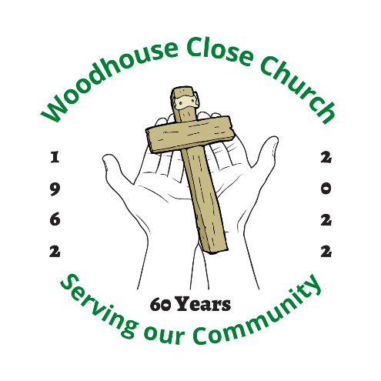

This year we celebrate 60 years

since the Church was built.

A service is in the planning stage

to take place in March

probably on a Saturday

followed by an afternoon

tea.

More details to follow.

|  |  |
| --- | --- |
|  |  |